 |  | Consumer Research Expert
ConsumerInsight Report
(Travel Report `19)
Company | ConsumerInsight |  | E-mail | kwonyg@consumerinsight.kr
Query | Kwon, Younggyo / Director |  | Phone number | 02) 6004-7622
Issued | Monday, Nov 11th 2019 |  | Pages | Total of 2 pages

‘Yanolja’ led the market for the three consecutive years… Can its dominance continue?
ConsumerInsight’s Travel product platform experience research

- Yanolja increased by 2.4%p in a year, widening the gap with the followers
- Agoda made it to the 2nd place… Skyscanner and Yeogiatae took the 3rd place together
- Traditionally strong global OTAs either remained in the same place or stepped backwards
- Activity specialized MyRealTrip and Klook grew distinctively

The dominance of Yanolja, the No. 1 travel product platform, has become even stronger. Yanolja took the top spot for three consecutive years, beating the chase with a 15.2% consumer experience rate within a year. Agoda climbed to the second place, stepping up 2 levels, and Skyscanner and Yeogiatae(Yeogiatae) were tied for the third place. Traditional global brands, Hotels.com, Booking.com, and Expedia, lagged behind in terms of experience rate and ranking.
With its ‘Annual Travel Product Satisfaction Survey’, ConsumerInsight, a travel research expert, summarized the results of the past three years on the use of web / apps (platforms) that specialize in booking travel products. 12,765 people were asked whether they had used major brands such as online travel agencies (OTA), metasearch (price comparison), and accommodation apps in the past year. The 24 brands covered are Agoda, Airbnb, Booking.com, Daily Hotel, Expedia, GogoSing, Hostelworld, Hotelscombined, Hotels.com, Kayak, KK-Day, Klook, Kyte, Mohaji, My Real Trip, Naver Airline/Hotel, Playwings, Skyscanner, Yanolja, Yeogiatae, Waug, Trip.com, Triple, Trivago (in alphabetical order).
△Yanolja ranked the first place with 15.2% [Figure 1] in the ‘experience rate’ over the past year, and the company has remained at the top spot for three years since 2017. △ Agoda ranked the second with 11.2%, △ Skyscanner and Yeogiatae shared the 3rd place with 10.5% respectively. While Yanolja exceeded 15% in experience rate for the first time, widening the gap with the 2nd place by 4%p, the rest in the leading group competed with a slight difference. The five brands in the mid-high tier group, such as △Hotels.com 9.2%(5th), △Airbnb 8.6%(6th), △Hotelscombined 8.4%(7th), △Naver Airline/Hotel 7.8%(8th) competed within the narrow range of 1.4%p. With some distance from those brands, Booking.com(5.3%) and Expedia(4.8%) were in the top ten.
If we look at the growth rate of 18 brands, excluding those 6 brands (GogoSing, KK-Day, Kyte, Mohaji, Playwings and Triple) that were added to the survey this year, we can see a rise in activity channels. The 11th place, My Real Trip, and the 12th place, Klook have doubled year-on-year growth (2.1%p and 2.5%p, respectively) and are ready to enter the upper middle. Second, Yanolja and Agoda, the No. 1 and No. 2, showed the steady growth of 2.4%p and 2.2%p, respectively. Third is the stagnation of the three global traditional powerhouses, the initial entrants to the Korean market. Hotels.com (+0.3%p) at the 5th place, Booking.com (+0.1%p) at the 9th place, and Expedia
(-0.5%p) at the 10th place all made almost no change. These brands’ growth engines seem to have fallen due to the aggressive marketing and activity channels by local brands.
[Figure1] Experience rate of Product Travel Platform (in the past year)
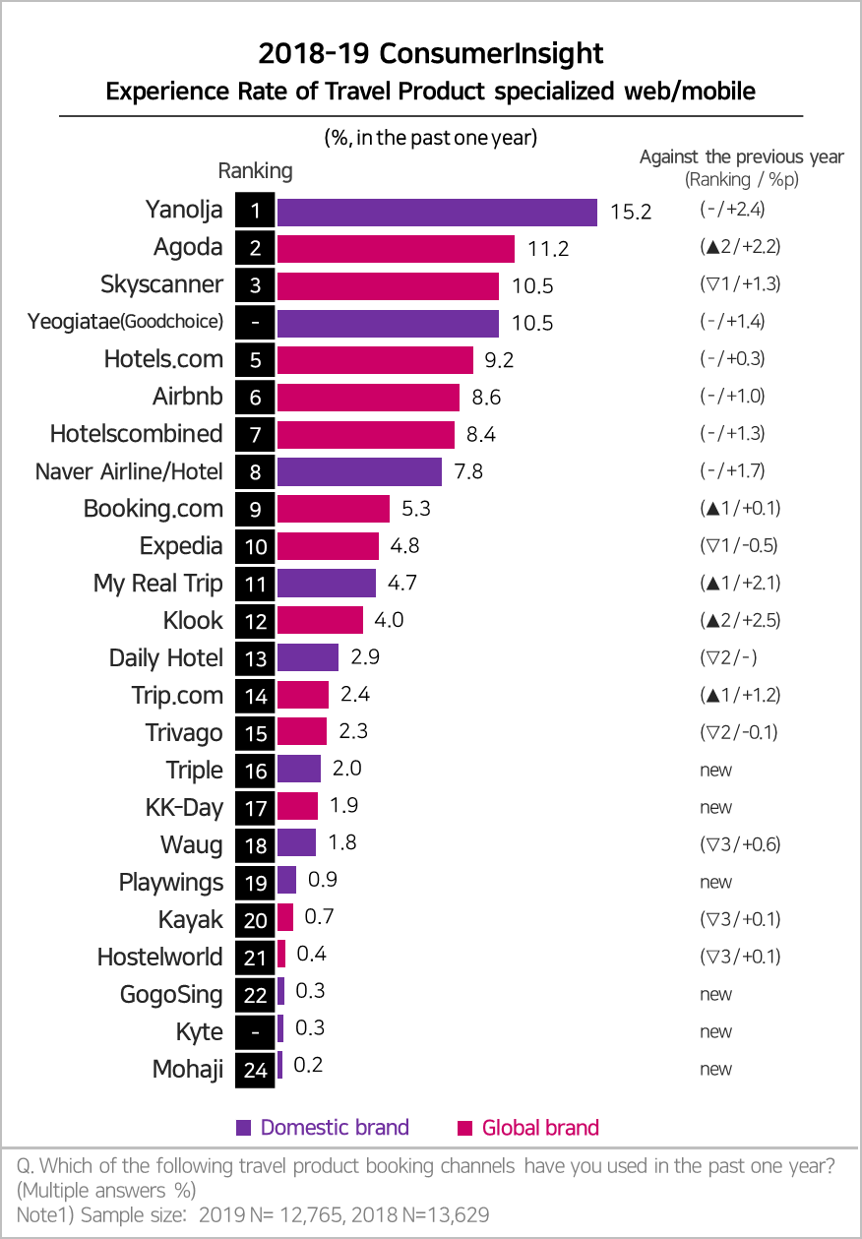

Consumer Trend Research Lab at ConsumerInsight has been conducting the survey on experience and evaluation of travel product platforms every year, since September, 2017. In 2019, the survey interviewed the total of 25,724 people out of ConsumerInsight’s 800,000 IBP (Invitation based panel), through the proportionate quota sampling by gender, age, and region. The data collection was done through email and mobile. The survey results and analysis reports can be viewed at www.consumerinsight.co.kr/etravel and the summary of the survey results of year 2018 and 2019 are downloadable. (Download Reports)
For-more-Information
Kwon, Younggyo / Director | E. kwonyg@consumerinsight.kr | T. 02)6004-7622

